**Name: Jesnamol Thomas**

**Roll No: 6**

**Batch: B**

**Date: 25/04/22**

**NETWORKING & SYSTEM ADMINISTRATION LAB**

**Experiment No.: 3**

**Aim**

Familiarization of linux command.

**Procedure**

**1.sudo useradd username:** Used for adding user.

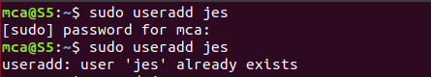

**2.sudo passwd username:**For creating password to user.

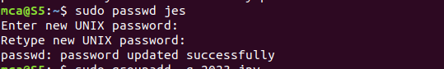

**3.sudo groupadd -g id groupname:**Used for creation of group.



**4.sudo usermod -G groupname username:**Used for add user to group.

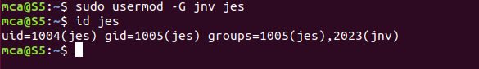

**5.compgen -g:**To view all groups

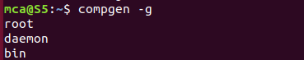

**5.compgen -g groupname:**To view that particular groups and user:

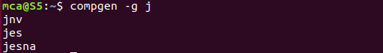

**6.sudo userdel username :**For deleting a particular user.



**7.sudo groupdel groupname:**For deleting a particular group.



**8.chmod +rwx** filename:To add, read,write and executable permissions.



**9.chmod -wx**filename:To take out write and executable permissions.

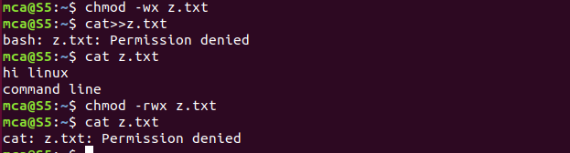

**10.chmod -rwx** filename:To remove read,write and executable permissions.



**11.sudo chown username filename:**To change the user ownership of a given file.

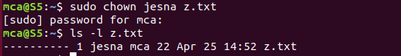

**12.ifconfig -a:**To configure or display the current network interface configuration information.

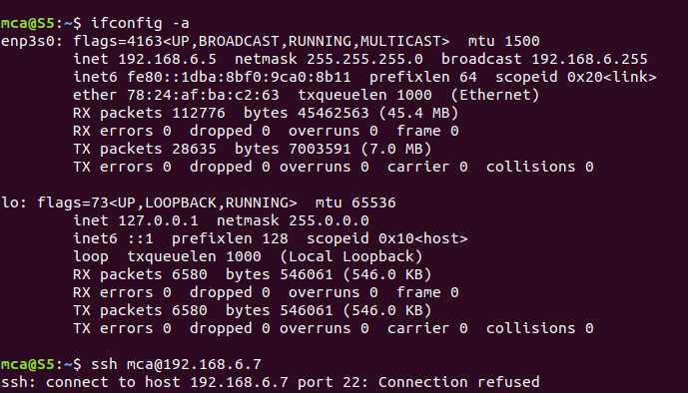**13.ssh mca**[**@ip**](mailto:mca@ip) **address:**To connect with other system using their ip adress.

